1. Rank the following functions by order of growth: n^2, n, log n, n!, n^n.

Answer: log n, n, n^2, n!, n^n

2. Show the result of each operation in the sequence PUSH(S,5), PUSH(S,2), PUSH(S,8), and POP(S) on an initially empty stack S stored in S[1,2,…,5].

Answer: 1 2 3 4 5
Push(S,5) → 5
Push(S,2) → 5 2
Push(S,8) → 5 2 8
Push(S) → 5 2

3. Show the result of each operation in the sequence ENQUEUE(Q,6), ENQUEUE(Q,3), ENQUEUE(Q,5), DEQUEUE(Q), ENQUEUE(Q,8), on an initially empty queue Q stored in array Q[1,2,...5].

1 2 3 4 5
ENQUEUE(Q,6) 6
ENQUEUE(Q,3) 6 3
ENQUEUE(Q,5) 6 3 5
DEQUEUE(Q) 3 5
ENQUEUE(Q,8) 3 5 8

4. Similar to the procedure Max Heapify, Min heapify performs the corresponding manipulation on a min-heap.
1) Writ the pseudocode of Min-heapify(A,i)

MIN-HEAPIFY(A, i)
l = LEFT(i)
r = RIGHT(i)
if l ≤ A.heap-size and A[l] < A[i]
smallest = l
else
smallest = i
if r ≤ A.heap-size and A[r] < A[i]
smallest = r
if smallest ≠ i
exchange A[i] with A[smallest]
MIN-HEAPIFY(A, smallest)

2) In the following min-heap, show the result after inserting 2( Write the result of each step)

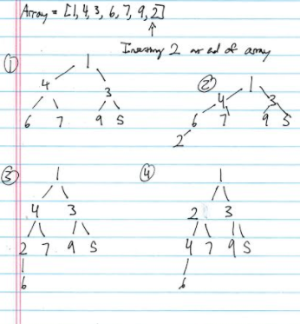

5. How would you modify the quick sort algorithm to sort a number sequence into increasing order using the 1st number of the sequence as the pivot? Use A = {9,12,1,7,4,21,16} as an example to illustrate your sorting process? (Write the result in each step)

Scan sequence
From 2nd number to last number
Or from last number to 2nd number
Or from both directions
Move values into two parts: smaller number part and larger number part
Move smaller number forward
Or move larger number backward

Ans 1: scan from 2nd number to last number and move smaller number forward
{9, 12, 1, 7, 4, 21, 16}: 12 > 9, no exchange;
{9, 12, 1, 7, 4, 21, 16}: 1 < 9, switch 1 and 12;
{9, 1, 12, 7, 4, 21, 16}: 7 < 9, switch 7 and 12
{9, 1, 7, 12, 4, 21, 16}: 4 < 9, switch 4 and 12;
{9, 1, 7, 4, 12, 21, 16}: 21 (and 16) > 9, no exchange;
→{4, 1, 7, 9, 12, 21, 16}: switch 9 and 4;
→ Or {1, 7, 4, 9, 12, 21, 16}: move 9 to middle.
Similarly, use the 1st number as pivot to divide each sequence into to two parts
{4, 1, 7} → {1, 4, 7} → {1}, {7}
{12, 21, 16} → {12, 21, 16} → {21, 16} → {16, 21} → {16}
Then, make a combination
{1, 4, 7, 9, 12, 16, 21}

6. Construct Huffman codes for the following set of frequencies {A:4, B:8; C:11;D:15;E:18;F:20;G:24}(Write the result of each step).

Note: The total of all is 100.
